Old Meeting, Tadley URC

Safeguarding

Children,

Young People

And Vulnerable Adults.

Policy and Guidelines

January 2019

4th edition

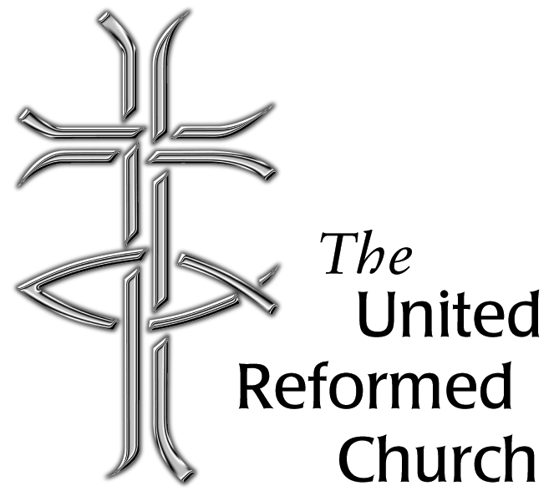

Inspirational text for Children’s Work

‘He took a little child and had him stand among them. Taking him in his arms he said, ‘whoever welcomes one of these little children in my name welcomes me; and whosoever welcomes me does not welcome me but the one who sent me’ (Mark:9 vv36 & 37)

Each person is precious to God and everyone needs the assurance that this brings. The Church is intended to be a place where all find healing and wholeness, where the child’s welfare is paramount and prevention of abuse is vital. There should be transparency and accountability in all dealings with children and there should be a partnership with statutory bodies at all times. A Christian approach to safeguarding children will expect individuals and communities to:

Create a safe environment for children, young people and their carers

Act immediately and sympathetically on any complaints made

Minister appropriately to those who have suffered abuse

Policy Statement
- Old Meeting, Tadley URC , aims to ensure that all young people, children and vulnerable adults are welcomed into a safe, caring, Christian environment with a happy and friendly atmosphere.
- As one of its major activities, Old Meeting, Tadley URC, seeks to serve the needs of young people, children and vulnerable adults promoting holistic development.
- In doing so, Old Meeting, Tadley URC takes seriously the welfare of all young people ,children and vulnerable adults who come on to its premises or are involved in its activities. It seeks to ensure protection from abuse regardless of gender, ethnicity, disability, sexuality or belief. There should be informed diligence about dangers of abuse thereby minimising the risk of harm.
- Old Meeting, Tadley URC, is committed to supporting, resourcing and training those who work with young people, children and vulnerable adults and providing supervision as necessary.
- Old Meeting, Tadley URC is committed to maintaining good links with the statutory child and adult care authorities. We should ensure that we keep up to date with national and local developments/guidelines relating to safeguarding issues. We should build constructive links with relevant statutory bodies.

January 2019
Signed......................................................
Date.........................................................

Aim & Contents
The safeguarding of children and vulnerable adults is about promoting the safety, well being and development of children, young people and adults at risk who are known to us, or are in our care through the church or associated activities. We aim to do this through a series of policies and guidance covering:-
1 Health & Safety:-
- Lettings
- Risk assessment ( building)
    - Standards and monitoring
    - Security
    - Fire Safety
    - Children and Photographs
    - First Aid
2. Events and Activities:-
- Safety
- Adult / Child Ratio
-indoor
-outdoor
- Outdoor Activities Away From Building
- Registration with local authorities
- Specialised work
-Detached work
-Special needs
-Holiday club

3. Transport

4. Workers Code of Conduct

- Behaviour Policy

- Parental Responsibility

- Insurance

- Website and Internet

- education of children about the internet

- Children with Medical Needs

- Child Protection and Protection of Vulnerable Adults :-

- Policy Statement
- Policy Guidelines
- DBS (disclosure and baring services) procedure
- Contact list
- Additional information -Appendices of flow charts and pro-forma forms for consent and record keeping.
- Health and Safety

Lettings

It is our policy that groups who hire or use these premises for children’s activities will have in place arrangements that comply with the Children Act 1989 and are consistent with the recommendations in the Code of Practice “ Safe from Harm”1999, issued by the Home Office, and this is clearly stated on the booking form. (See appendix 1)

Should it become apparent that the arrangements put in place by a hirer are inadequate, not meeting the standards of our own policy for the protection of children and vulnerable adults, the elders of Old Meeting, Tadley URC reserve the right to terminate or refuse a booking.

Risk Assessment- Safety within the Building

We aim to ensure a safe environment for work with children, young people and vulnerable adults by minimising potential hazards through the following practice and procedures:-

- Premises will be warm, well lit and well ventilated.
- They should be kept clean.
- They should be free from clutter.
- Electric sockets should be covered.
- Any problem with the above or other potential hazards noticed should be reported as soon as possible to the Elders or Minister OR by e-mail to the church secretary.(contact@tadleyurc.com)

Standards and monitoring

- In order to maintain a safe environment for work with children and adults at risk this policy document and practice will be reviewed annually and any changes will be acknowledged by the church meeting and the elders’ meeting.

Fire Safety

- In the event of the fire alarm sounding, the first duty of all staff and volunteer helpers is to evacuate all children, young people and vulnerable adults from the building by the nearest exit. Group leaders should bring attendance registers with them. The exits are the front door of the Church or through side room (alternative side door) or the front and rear of the Immanuel Centre hall.
- In case of evacuation all venue users should make their way via the nearest exit point from the building to the fire assembly point which is on the plot of land to the side of the Immanuel Centre behind the large beech hedge. (to enable drive and car park to remain clear for Fire brigade access)
- No one should leave this assembly point without notifying the member of staff responsible for the group.

Security

- All persons caring or working with children should ensure that no unauthorised person can gain access to the children. Activity leaders have the authority to challenge any unauthorised person who insists on remaining in the area. If this is unsuccessful then assistance should be sought or the children should be removed from the area.
- Children should not be able to leave the premises unsupervised.
- Young people and vulnerable adults should not leave the premises unchecked.
- Identify all visitors before allowing them access to the building or area you are occupying.
- Name and identify to the children and young people the leaders of any event that they are attending.
- Do not allow any child to leave with someone unknown to you before checking.

Children and Photographs

- Permission must always be gained from a parent or carer who has parental responsibility before pictures or films of a child are taken.
- When displaying any photographs do not identify individual children by name, age or where they may be found.
- Displaying groups of children is considered to be a safer option.

First Aid

- The First Aid kits are located in the kitchen of the Immanuel centre (for use in the kitchen only), in the foyer of the Immanuel centre, where church policies are kept, and in the church building First Aid kit is located in the kitchenette area of the Side Room.
- The first aid supplies should be regularly checked and re-stocked as needed by the site first aider nominated by the church meeting.
- All groups of children and young people should endeavour to have a specified first aider.
- Always complete an Accident Report book sheet (located on the bookshelf in the foyer of the Immanuel centre) when any injury has occurred.
- Ideally every group will have at least one leader with a mobile phone for emergencies.
- Disposable medical gloves and a disposable apron (available in the first aid kit) should always be used when dealing with broken skin, body fluids and faeces.
- Tablets and creams should not be added to the First Aid kit.
- Medication should NOT be administered (but see the section for children with medical needs).
- If an incident occurs but does not cause bodily harm it should still be recorded on an incident form (located in the folder on the bookshelf by the kitchen).

- Events and Activities

- Safety

In addition to the 13 ‘Safe from Harm’ guidelines (see appendix 1 for details) consideration should be given to the following good practice guidelines to ensure the establishment of a safe environment for work with children, young people and vulnerable adults. The Children Act 1989 introduced new regulations and recommendations for statutory and voluntary bodies which run facilities for the under-8s. Although only certain groups have to register with the local authority, its recommendations should be considered for all children when providing a safe and secure environment.

When organising indoor events or activities attention should be given to check that:-
-Meeting places are warm, well lit and well ventilated.
-They are kept clean and free from clutter.
-Electric sockets are covered.
-A mobile phone is available or the location of one is known.
-A register of those attending and leading is kept.
-A ‘signing in and out’ procedure is adopted for a youth group.
-Other people entering the building, who are not part of the event, are monitored.
-Adult to child ratios are appropriate.

- Adult / Child Ratios

The ratios given below are a minimum and may need to be increased for groups with special needs. Avoid working alone with a group or individual child/young person, however when such work is required ensure you are visible to other adults, or that another worker is aware that a meeting is occurring. Parental consent should be gained when appropriate.

Indoor Activities
These are the required minimum staffing levels for children’s groups. More help will be required if children are being taken out or undertaking physical activities.

0-2 years 1 leader for every 3 children
2-3 years 1 leader for every 4 children
3-8 years 1 leader for every 8 children
Over 8 years 1 leader for the first 8 children and one extra leader for every extra 12

Each group should have at least 2 workers and it is recommended that a gender balance be maintained. If groups are in the same room, one person per group is allowed.

Young people aged between 14 and 18 may help groups but should be supervised by an adult helper who will be responsible for ensuring that good practice and the child protection procedures are followed.

If an adult, child or young person under 18 needs to speak on a one-to-one basis, ideally another adult should be made fully aware of the meeting and be available until it ends and any such meeting should be carried out in as open an area as possible.

Outdoor Activities

Events in the neighbourhood of the building require the same care and attention during the planning stage. The area being used should be risk assessed for each group paying particular attention to wild and uncultivated plants such as toadstools, and that all areas are safe and secure. The adult/child ratio should be increased.

0-2 years. 1 leader for every 3 children
2-3 years. 1 leader for every 4 children
3-7 years. 1 leader for every 6 children
8-13 years. 2 leaders (preferably one of each gender) for the first 15 children and one additional leader for every 1-8 extra children
13 years and over. 2 leaders (preferably one of each gender) for the first 20 young people and one additional leader for every 1-10 extra young people.

- Outdoor Activities away from the buildings.

Various forms are available to help the organisation and planning of these activities. Copies of these are attached and should be used for each newly organised event.
They include:-
- Risk assessment form
- Parental consent and medical form

Other important issues to highlight:-

- The reason for the outing / visit and its objectives
- Date and duration
- Venue. It is the organiser’s responsibility to check that the venue and its staff meet all health and safety requirements.
- The make-up of the group. Consider any special needs and how you will respond to them.
- Appropriate staffing
- Resources, including costs
- Transport options
- Exploratory visit
- Emergency procedures, including participant details left with a church Elder not party to the activity itself.
- Insurance
- Information to and from parents
- Preparation of group. Include group participation in the planning appropriate to their age and ability.
- Evaluation

- Registration with the local authority.

Groups that include children who are under 8 years old, and meet for more than two hours in any one day or for a total of more than 6 days a year (e.g. a holiday club), must register with the local authority. Registration includes standards for leaders as well as premises which will be advised by the local authority.

-Some local authorities give a maximum number of children permitted in any one room, but as a guide each child should have 2.3 square metres of unencumbered space.
-1 toilet and 1 hand basin per 10 children is ideal. A safe outdoor area is recommended if children meet for more than 4 hours. A quiet area is also useful.
-If food is regularly prepared for children on the premises the facilities will need to be checked by the environmental health officer and a Food Handling and Hygiene certificate is required. Children’s lunches should be kept refrigerated. Drinks should always be available.

- Specialised Work

Outreach and Detached Work
At present there are no workers or volunteers who engage in outreach or detached work. Should this become a resource from the Old Meeting, Tadley URC then the appropriate policy and procedure will be inserted into this document.

Special Needs

Children with special needs are welcomed and facilities are available.

Holiday Club
At present the Old Meeting, Tadley URC does share responsibility for a Holiday Club with other churches in the area. Such activity is undertaken under the guidance of a steering committee and they adopt the current Tadley Common Methodist policy in order to suit the requirements of the hosting Church for the club.

- Transport

When planning transport for trips and outings many factors have to be considered and should be included in the risk assessment whether you are using private, public or hired transport with a driver. Factors to consider are:-
- Type of journey, including journey time and distance
- Passenger safety
- Traffic conditions
- Weather
- Arrangements for emergencies and breakdowns
- Appropriate insurance cover
- Stopping places
- Supervision

Whenever possible, children and young people should be transported to events by their own parents/guardians. However, in situations where this is not practical, a volunteer may be asked to transport a group of children or young people and then these processes should be followed:-
- Children and young people should not be transported by private car without the prior written consent of the parents.
- For events run by the Church, the driver’s documents must be seen and approved by the organizing Church. This will mean that the driver will be asked to show proof of a current driver’s licence, along with current MOT and insurance documents for the car to be used. They will also need to fill out and sign a declaration form (sample form is at the end of this document) to disclose any driving offences committed within the last two years and the severity of any such offences should be checked through the DVLA by the Church organiser. All drivers will be held responsible for ensuring the road worthiness of the car they are driving for the event and for the general safety of their passengers at all times.
- Children under 4ft 5inches or eleven years of age must use a child safety seat supplied and fitted by their own parent/guardian.
- Two adult helpers (at least one of whom must have a current DBS check done through the Church) should be in every car (ideally one female and one male) and children should be positioned in the rear seats of the car.

- Workers Code of Conduct

Workers Code of Conduct

Protect the rights and promote the interests of children,young people and vulnerable adults by:-
  - Treating each person as an individual
  - Respecting and where appropriate promoting their views and wishes
  - Respecting and maintaining their dignity and privacy
  - Respecting their diversity and different cultures and values.

Strive to establish trust and confidence by:-
- Being honest and trustworthy
- Communicating in an appropriate, open, accurate and straightforward way
- Being reliable and dependable

Protect, as far as possible, from danger and harm by:-
- Using established processes and procedures to challenge and report dangerous, abusive, discriminatory or exploitive behaviour and practice
- Complying with the church’s health and safety policies
- Highlighting any difficulties that might get in the way of delivering safe care.

5. Children and Young People’s Behaviour Policy

There is an expectation of respect from all children & young people when attending groups in this church. This includes respect for one another, for staff, for themselves for other users of the building. It is up to individual users to establish & implement their own rules of behaviour.
- Groups should report situations when bad behaviour or bullying has occurred but no physical injury has been sustained in an incident book which is kept confidential but is regularly monitored by the group leaders.

6.Parental Responsibility- (under the Children Act of 1989)

Parental Responsibility is concerned with the power to make decisions in relation to a child. It is defined as
‘all rights, duties, powers, responsibilities and authority which by law a parent of a child has in relation to the child and his/her property’.

The following people have responsibility under the Children Act 1989:-
- The mother of a child whether married or unmarried
- The father of a child if he is married or was married to the mother at the time of child’s birth
- An unmarried father if he has acquired parental responsibility through a court order or agreement registered in court
- Any person who holds a residence order in relation to the child
- The Local Authority which shares responsibility with a parent/parents if a child is the subject of a care order
- The parents of an adopted child.

Each person sharing parental responsibility may act alone, i.e. one parent may act without the consent of another.
If one parent does not agree with the other about a matter concerning the child, application through a court should be made.
Any person with parental responsibility may delegate some or all of it.

Where an organisation is looking after a child for a period the organisation is responsible for the child and has a duty to safeguard the child’s welfare.

A written record providing the following should be kept:
- The child’s/young person’s details, name, address etc.
- Details of each person with parental responsibility
- Any particular instructions regarding the child/young person (e.g. who should collect the child etc.)
- Where there are specific instructions all staff should know what they are and how to carry them out
- The organisation should have written procedures for recording events, involvement of police etc to cover the eventuality of any dispute arising between the parents and the organisation.
7.Insurance

All groups running activities from these premises, or on behalf of the Church, are responsible for ensuring they have appropriate insurance cover for the activity that is planned. For church activities please speak with the church treasurer.
Groups that are not run by Tadley United Reformed Church are fully responsible for ensuring that they have their own appropriate insurance in place before carrying out any events at Tadley United Reformed Church.

8.Website and Internet

Written parental consent must be obtained before any images of children are placed on the church website.
Children can be targeted through the church website. Care should be taken not to identify children in this way.
Pictures need to be selected with care so that they cannot be downloaded and manipulated by anyone viewing the site.
Advice is given in ‘Good Practice’ 4 for the checking of computers for improper use and may be used in the prevention of downloading inappropriate material by adult or child users.
Church volunteers and workers may wish to use modern media as a tool for communicating group events but it must not be used for entering into private conversations. It is advisable that records are kept of all correspondence.

Education of Children about the Internet

Where appropriate educate children to use the internet responsibly.
Be aware of children and chat room vulnerability. We currently have no internet access in either the church or the Immanuel centre at Old Meeting, Tadley URC.

9.Children with Medical Needs

Medication can be administered to children with specific medical needs with permission and full instruction from the parent/carer.

10.CHILD PROTECTION and PROTECTION OF VULNERABLE ADULTS

Policy Statement:

Old Meeting, Tadley URC recognises that it is the responsibility of each one of its staff, paid and unpaid, to prevent the neglect, physical, sexual or emotional abuse of children, young people and vulnerable adults and to report any abuse discovered or suspected.

The purpose of this part of the document is to ensure that those working with children and adults at risk recognise that some do get abused, and to advise the appropriate action if a complaint is made or abuse is suspected.
First and most important, whether it is your first contact with suspected abuse or not:-
a) Ensure the welfare of the child, young person or vulnerable adult.
b) Talk to someone.
Should you encounter any situation involving a child, young person or vulnerable adult which gives you cause for concern, make a written note of the conversation, observation, dates, times, names, etc. Pass on this information immediately to the church Safeguarding Officer (David Bennett or Janet Gross) in order for them to make a decision on what action should be taken and if social services need to be contacted
Do not be afraid to be wrong. What if you’re right?
- Policy Guidelines:

Who is a child or young person?
For the purposes of this policy any person under the age of 11years is considered a child and person between 11-18years is considered a young person.
Who is a vulnerable adult ?
A person, over the age of 18 years, who is permanently or temporarily unable to care for themselves or their interests.

What is abuse?
a) Physical abuse – Physical injury to a child which may have been deliberately inflicted or knowingly not prevented.
b) Neglect - Persistent failure to meet a child’s basic physical and/or psychological needs.
c) Emotional abuse – Severe adverse effect on the behaviour and emotional development of a child by persistent or severe emotional ill treatment or rejection. This also includes bullying, harassment and persistent sarcasm.
d) Sexual abuse - Involvement in sexual activities which children/adolescents do not truly comprehend and/or have not given consent to.
(A child may suffer more than one category of abuse)
In addition, a vulnerable adult may suffer the following types of abuse –
e) Financial or material abuse –The inappropriate use,misappropriation,embezzlement or theft of money,property or possessions.
f) Discriminatory abuse – This is the inappropriate treatment of an adult at risk because of their age,gender,race,religion,cultural background,sexuality,disability etc. Discriminatory abuse exists when values,beliefs or culture result in a misuse of power that denies opportunity to some groups or individuals. Discrminatory abuse links to all other forms of abuse.
g) Institutional abuse – This is the mistreatment or abuse of an adult at risk by a regime or individuals within an institution (eg hospital or care home ) or in the community. It can be through repeated acts of poor or inadequate care and neglect or poor professional practice.

Who abuses children?
- very rarely a stranger
- often someone close to a child, e.g. parent, carer, baby-sitter, sibling, relative or friend of the family
- sometimes, someone in authority such as a teacher, youth leader, children's worker, or, very sadly, a church worker/leader
- sometimes, paedophiles and others who set out to join organisations (including churches) to obtain access to children.

How might we recognise abuse?
Warning signs: These are only a guide and not necessarily proof, but may be an indication of abuse: -
a) Changes or regression in mood or behaviour, particularly where a child withdraws or becomes clinging
b) Nervousness/watchfulness
c) Sudden under-achievement or lack of concentration
d) Changed or inappropriate relationships with peers and/or adults
e) Attention seeking behaviour
f) Persistent tiredness
g) Running away/stealing/lying

Other areas where leaders should be vigilant are:-
a) Any injuries not consistent with the explanation given for them, or where differing explanations have been received
b) Injuries which occur to the body in places which are not normally exposed to falls rough games, etc.
c) Injuries and illnesses which have not received medical attention
d) Instances where children are kept away from the group or school inappropriately
e) Reluctance to change for, or participate in, games or swimming
f) Any signs of neglect, under nourishment or inadequate care
g) Any allegations made by a child concerning sexual abuse.
h) Child with excessive preoccupation with sexual matters, and detailed knowledge of adult sexual behaviour, or who regularly engages in age inappropriate sexual play
i) Sexual activity through words, play or drawing
j) Child who is sexually provocative or seductive with adults
k) Inappropriate bed sharing arrangements at home
l) Severe sleep disturbance with fears, phobias, vivid dreams or nightmares, sometimes with overt or veiled sexual connotations.

One or more warning signs may be evident
Many symptoms of distress in a child can point to abuse, but there are other explanations too. This, together with conflicting medical opinion, has sometimes been the reason for falsely accusing parents of sexual abuse. It is important that the above signs are not taken as indicating that abuse has taken place, but that the possibility should be considered far more than in the past. They should make us stop and think - not jump to conclusions inappropriately!
Recognising Triggers of Abuse
Rather than talk about ‘recognising abuse’ you might also consider ‘Sources of Stress’ which may lead to abuse. These might include:
Social Exclusion Vulnerability Domestic Violence Mental Health
Drug and/or alcohol misuse Learning Disability and lack of Parenting Capacity
Disability of the child Children as Carers Family change, Loss, Bereavement

What to do if abuse is suspected
a) We have a responsibility. The Children Act 1989 is intended to promote the welfare of all children and states that:
"The community as a whole has a responsibility for the well-being of children. This means that all citizens should remain alert to circumstances in which children may be harmed. Individuals can assist the statutory authorities by bringing cases to their attention. Relatives, friends and neighbours of children are particularly well placed to do so, but they must know what to do if they are concerned, in addition to providing support for the family and child, which may include help caring for the child. They must also be confident, because of the difficult and sensitive nature of the situation, that any information they provide will be treated in a confidential way and used only to protect the interests of the child. They should know too that early action on their part is often the best way of helping a family stay together as well as protecting their child".
b) Social Services note the following in their preamble when dealing with voluntary social work agencies involved in child care.
(i) Voluntary agency staff involved with families and children are likely to receive referrals/information/allegations or witness concerns suggestive of the need for a child protection investigation under section 47 of the 1989 Children Act. It is the responsibility of the voluntary agency to refer concerns to the Children’s Social Care.
(ii) The role of the voluntary agency in these circumstances, except in the case of medical emergency, is essentially to collect and clarify the precise details of the allegation, and provide information to the Children’s Social Care, whose task it is to investigate under section 47 of the 1989 Children Act.

The role of the voluntary agency is not an investigative one.

Responding to abuse

If a child has a physical injury or symptom of neglect:
Contact your church ‘link’ person immediately.
In children’s work here at Tadley URC this is either David Bennet or Janet Gross and they will take the following actions.
- Speak with the parent and suggest medical help/attention is sought for the child. The doctor will then initiate further action, if necessary. Alternatively, encourage the parent to seek help from the Children’s Social Care.
- If a parent is unwilling to seek help, then you may offer to go with them. If she/he fail to act you may need to seek help yourself, i.e. via Social Services.
- Where emergency medical attention is necessary then this should, of course, be sought immediately, informing the doctor of any suspicions you may have.
Any reports of suspected abuse which are reported to David Bennet or Janet Gross need to be documented and a copy sent to Sharon Barr at Wessex Synod. There is a standard form for David Bennett and Janet Gross to complete in the event of an incident.

If there are allegations of sexual abuse:
- Contact your church ‘link’ person (David Bennet or Janet Gross) immediately or contact Social Services or the Police direct for advice. Do not speak to the parent (or anyone else) if there is a possibility that they could be involved. The fact that you may feel the child's story is unlikely must not prevent appropriate action being taken. For example, a child may say that he/she has been abused by an older young person. In reality, the perpetrator could be a parent or close relative, but naming another person may be the only way in which this child can seek help.
- It is the responsibility of the church ‘link’ person to pass on the possibility of abuse to the Children’s Social Care. The role of the church is essentially collecting and clarifying the precise details of the allegation and providing the information to the Children’s Social Care, whose task it is to investigate the allegation.

Further guidance in responding to abuse:
Whilst the church worker will normally consult with their church ‘link’ worker before reporting incidents/suspicions of child abuse to the Children’s Social Care, the absence of the church ‘link’ person should not delay referral to the Children’s Social Care. Exceptionally, should there be any disagreement between the worker and ‘link’ person as to the appropriateness of such a referral, the church worker nevertheless retains the right as a member of the public to report serious matters to the Children’s Social Care.
All children's workers should be aware that any allegations or suspicions are covered by pastoral confidentiality, and that church members have no rights to this information. The sharing of information is therefore limited to a Need to Know basis. This will protect the interests of all the parties concerned.

Third party /anonymous referrals/allegations:

Families not known to the church:
- In cases where allegations are made by a third party, the role of the church worker is to elicit as much information as possible from the referrer. Unless the person wishes to remain anonymous this should include the referrer's details (name, address, telephone number) and as much factual detail as possible about the child and family concerned (names of family members, address, name /date of birth of subject child, ethnic origin, etc.). Information as to the cause of concern/nature of injuries/observations should be included.
- The church worker must inform the referrer that information relating to any child at risk, will be shared with their church ‘link’ person and may result in referral to the Children’s Social Care, and in this event the Children’s Social Care may wish to interview the referrer (if known) as part of the child protection investigation.
- The church worker will then report the above information to the church ‘link’ person and the latter will then seek the advice of the Children’s Social Care.

Families known to the church:
- In cases of families known to the church where the church suspects from either direct observation, a third party, from the child or from a parent/carer, that the child is suffering or has suffered sexual abuse, the matter must be reported immediately to the church ‘link’ person (David Bennet or Janet Gross) with a view to referral to Children’s Social Care and to the Church Secretary if a church worker or leader is implicated.
- Should a child allege sexual abuse, the parents should not under any circumstances be informed. Where a parent/carer alleges sexual abuse by another person, the parent/carer should be advised not to inform the alleged perpetrator. Should the church worker by direct observation suspect sexual abuse, they should discuss this immediately with the church ‘link’ person, with a view to discussion with Social Services as to how the matter will be dealt with.
- In cases of physical, emotional abuse or neglect, where the church worker, by observation, considers that such concerns exist, he/she should consult with the church ‘link’ person who will seek the advice of the Children’s Social Care as to appropriate action. Normally in these circumstances the church ‘link’ person will inform the parent of his/her duty to refer such concerns to the Children’s Social Care and the probability of interview by a social worker and/or police officer. Of course, in cases of serious injury the church worker should summon medical help immediately.

How should we react if a child wants to confide?
Children's workers are in a unique position and their relationship with children cannot be underestimated. Their group may be providing a safe haven, and perhaps the only place where a child feels comfortable and able to talk to adults. It is therefore possible that a child may approach you to talk about abuse.

The following guidance may be of help:-

a) General points:-
(i) Accept what the child says.
(ii) Focus on listening / listen carefully.
(iii) Respond to the child’s cues.
(iv) Give encouragement, validation and reassurance. Go at a pace that is comfortable for the child.
(v) Let him/her know that you will need to tell someone else – and address the child’s concerns.
(vi) Even when a child has broken a rule they are not to blame for the abuse.
(vii) Be aware the child may have been threatened.
(viii) Make notes as soon as possible, writing down exactly what the child said, including the child's name, age, address, relevant family information, and details of the situation and the activity that preceded disclosure.
(ix) Never push for information or question the child.

(x) The church link person should record all conversations in which allegations of abuse are made (either with the alleged abused person or the person reporting such alleged abuse to the link person). All records of these conversations should be securely kept in the specified locked drawer, to which only the Link Persons have access.

b) Helpful things to say:-
(i) “I believe you”
(ii) “I am glad you have told me”
(iii) “I’m sorry this has happened to you”
(iv) “I am going to help you, and will tell you what I’m going to do”

c) Avoid saying:-
(i) Why didn't you tell anyone before?
(ii) I can't believe it.
(iii) Are you sure this is true.
(iv) Why? How? When? Who? Where?
(v) Never make false promises.
(vi) Never make statements such as "I'm shocked, don't tell anyone else"

d) Concluding: - (see Appendix IV for reporting flow chart)
(i) Again reassure the child they were right to tell you and that you believe them.
(ii) Let the child know what you are going to do next, and that you will let them know what happens.
(iii) Immediately refer to your church ‘link’ person.
Even if the abuse is no longer happening it is still important to report the matter, as the adult may be abusing other children. Also it may be that the child will need guidance and help in overcoming the effects of the abuse, plus the police may wish to prosecute.

Practicalities for mutual protection of leaders and children involved in children's work (see Appendix II)

i) Guidance
a) Avoid being on your own with any child. This may mean groups working in one large room, or adjoining rooms.
b) Never take a child home on your own - preferably have another helper with you, or else ensure that the last two children are dropped off together.

(Remember an allegation could also be made against you!)
c) Be wise in your physical contact with children.
d) Be wise with your relationship with the children - do not be over friendly with some at the expense of others. No favourites.
e) Male helpers need to be particularly careful in what they say, and in being around forward young females. Female helpers similarly need to be careful with forward young male children.
f) Never smack, hit or physically discipline a child except by "holding" which may be used if there is an immediate danger of personal injury to the child or another person.
g) If you feel that a child may have a "crush" on you, talk to your Church link person or the person responsible for managing your group for advice and guidance.
h) In order to help children, we need to develop healthy relationships by listening to them and respecting them.
i) We must be mindful of the safety of the children at all times, and in all circumstances.
j) Whenever possible have two adults present with a group, particularly when it is the only activity taking place on the church premises and do not take a group off the premises with fewer than two adults.
k) Where confidentiality is important (e.g. counselling a young person) ensure that others know that the interview is taking place and arrange to be in a place that you can be seen but not overheard.

ii) Boundaries
a) The level of personal care (e.g. toileting) should be appropriate and related to the age of the child - accepting that some children have special needs.
b) Guidance on touch. For example, physical contact between adults and children can be quite healthy and is acceptable in certain circumstances and in public places. Any touching should be to suit the child’s needs and not the adult’s.
c) Workers should treat all children/young people with dignity and respect in attitude, language used and actions.
d) Respect the privacy of children; avoid questionable activity (e.g. rough/sexually provocative games or comments).
e) If you invite a child to your home, ensure another adult is present and the parent is aware.
f) Try to avoid transporting children on their own, but if you have to then it is better that the young person is in the back seat.

iii) Feedback
a) It should be accepted that anyone seeing another worker acting in a way which could be misinterpreted should be able to speak to the individual or the Church link person about the concern.
b) Procedures should be reviewed regularly to ensure a common approach, concerns should be shared and matters which may need clarification and guidance should be identified.
c) Reporting back to the workers’ meeting should be encouraged when departure from guidelines has become necessary. This provides protection to the individual and draws the leadership's attention to shortcomings and problem areas.
d) Keep brief records of issues/decisions discussed at workers meetings.
e) Should you need to be formally disciplined for inappropriate behaviour, we will have to notify the Disclosure & Barring Service (DBS)

iv) Help children to protect themselves by:
a) Teaching safety generally including strangers, good and bad secrets and touches etc.
b) Teaching children common sense rules.
c) Talking about suspicions or situations where they may feel uncomfortable.
v) Examine the way in which we present Christian truths; for example, children obeying parents. This can be a real problem for a child who is being abused - are we telling the child to accept the abuse? Tell children that if they feel uncomfortable or that something may be wrong, they can always check things out with another adult.

Confidentiality:-
No children's worker is permitted to divulge any information concerning a child, or his/her family or anything a child may tell them to anyone other than the designated people previously mentioned. This is in order to protect the interests of the child. This confidentiality is a continuing requirement at all times and is required when workers are "off duty" or no longer involved in the work.
- DBS Application and procedures:-
It is the policy of Old Meeting, Tadley URC, that all adults, whether voluntary or employed, who frequently work with children and young or vulnerable people should undergo an enhanced Due Diligence check (DDC). For church related workers, the forms for these checks will be dispatched and verified by Janet Gross.

The Elders of this Church reserve the right to prevent any adult working with the children and young or vulnerable people of this Church if they have any doubts as to the suitability of that adult.

It is the Church’s policy that approximately every five years all adults, whether voluntary or employed, who regularly work with children and young or vulnerable people should undergo a DDC check.

It is recommended that Janet Gross
- oversees DDC certificates
- ensures that records of those holding DBS certificates are kept up to date
- that people are reminded when their DBS is due for renewal

Whilst DDC certificates are being processed it may, in certain situations or for special events, be required that helpers fill out the Church’s own volunteer’s declaration form as an intermediary measure.

However, the Church recognises that DDC checks are not a safeguard in themselves. All adults working with children and young or vulnerable people in this Church, whether voluntary or employed, have a duty to be vigilant at all times and in every situation.

CONTACT NAMES

Church ‘Link’ Persons
- David Bennett Tel: 07926 122020 (Primary Link)
- Janet Gross Tel:0118 970 0809 (Secondary Link, only to be used when David Bennett is unavailable)
Church Secretary
- Paul Gross Tel: 0118 970 0809
Church Wessex Synod Safeguarding Officer
- Sharon Barr Tel: 07776 178246

Children’s Social Care - Hants Direct

Tel. 01329 225379

(Out of Hours) Children’s Social Care 08456 004555

Vulnerable Adult Social Care – Hants Direct

Tel. 0300 555 1386

(Out of Hours) Tel. 0300 555 1373

Police 0845 0454545

NSPCC Child Protection Help Line 0808 800 5000

Child-Line 0800 1111

For further advice on matters of safeguarding children and vulnerable adults please contact the United Reformed Church at Tavistock Place in London Tel: 02075202729 or via their website:safeguarding@urc.org.uk

11.Additional Information

APPENDIX I ‘Safe from Harm’

APPENDIX II guidelines for staff working on their own with children/young people

APPENDIX IV Flow chart for dealing with disclosure of abuse

FORMS (to be copied and returned to file please or obtain e-copy from church secretary)

Page 28-31 (pack to be given to any new volunteers)

“The Fun Starts Here”

Volunteer Application Form

Volunteer Reference and Declaration Form

Current Voluntary Roles at Tadley URC

Pages32-34- Example of parental consent for planned activity (to be adapted as appropriate but any changes need to be approved by Paul Gross or David Bennett before issue) & Consent for transport (to be completed by parents in conjunction with planned activity consent form when transport required)

Page 35-36-Example of approved driver declaration (for office records)

Risk assessment form (to be copied and returned to file please or obtain e-copy from church secretary. Forms can be adapted with approval from church secretary.)

Daily checklist (to be copied and returned to file please or obtain e-copy from church secretary. Forms can be adapted with approval from church secretary)

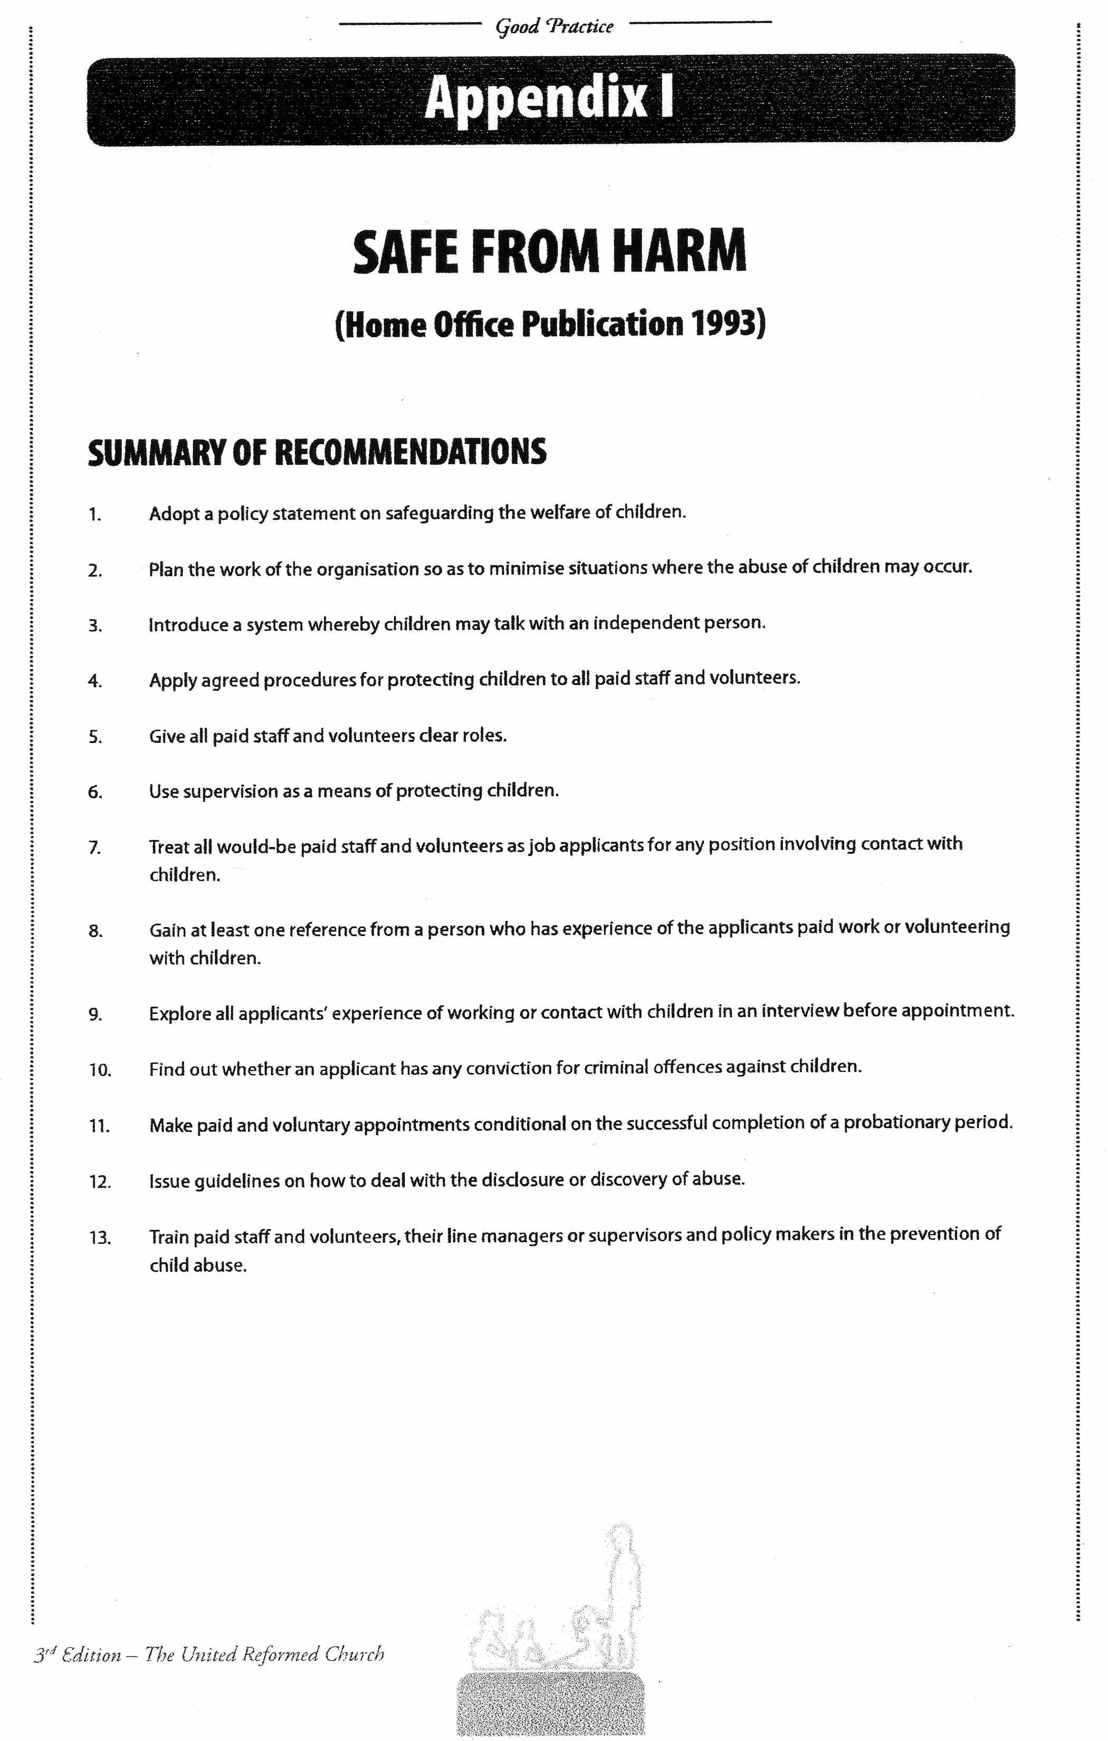

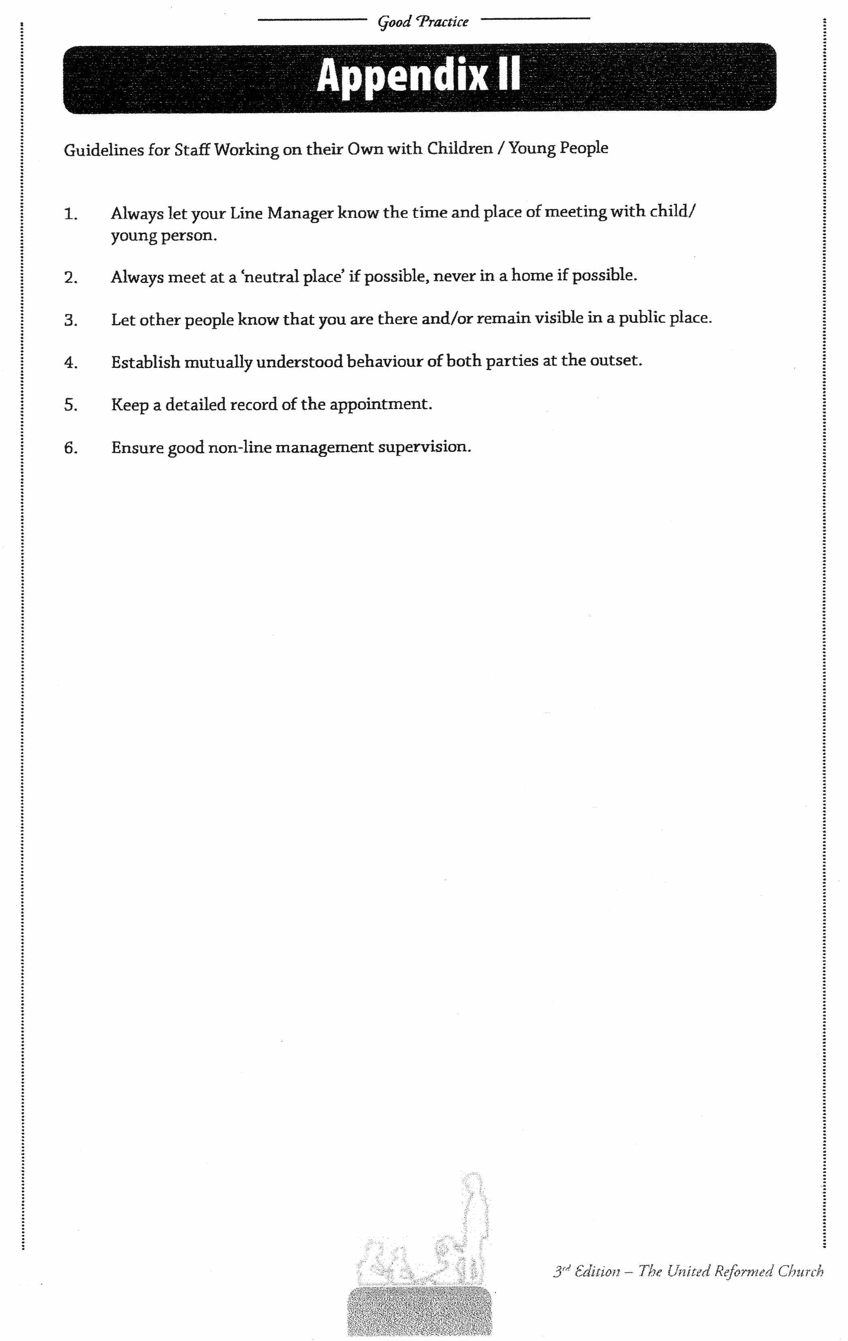
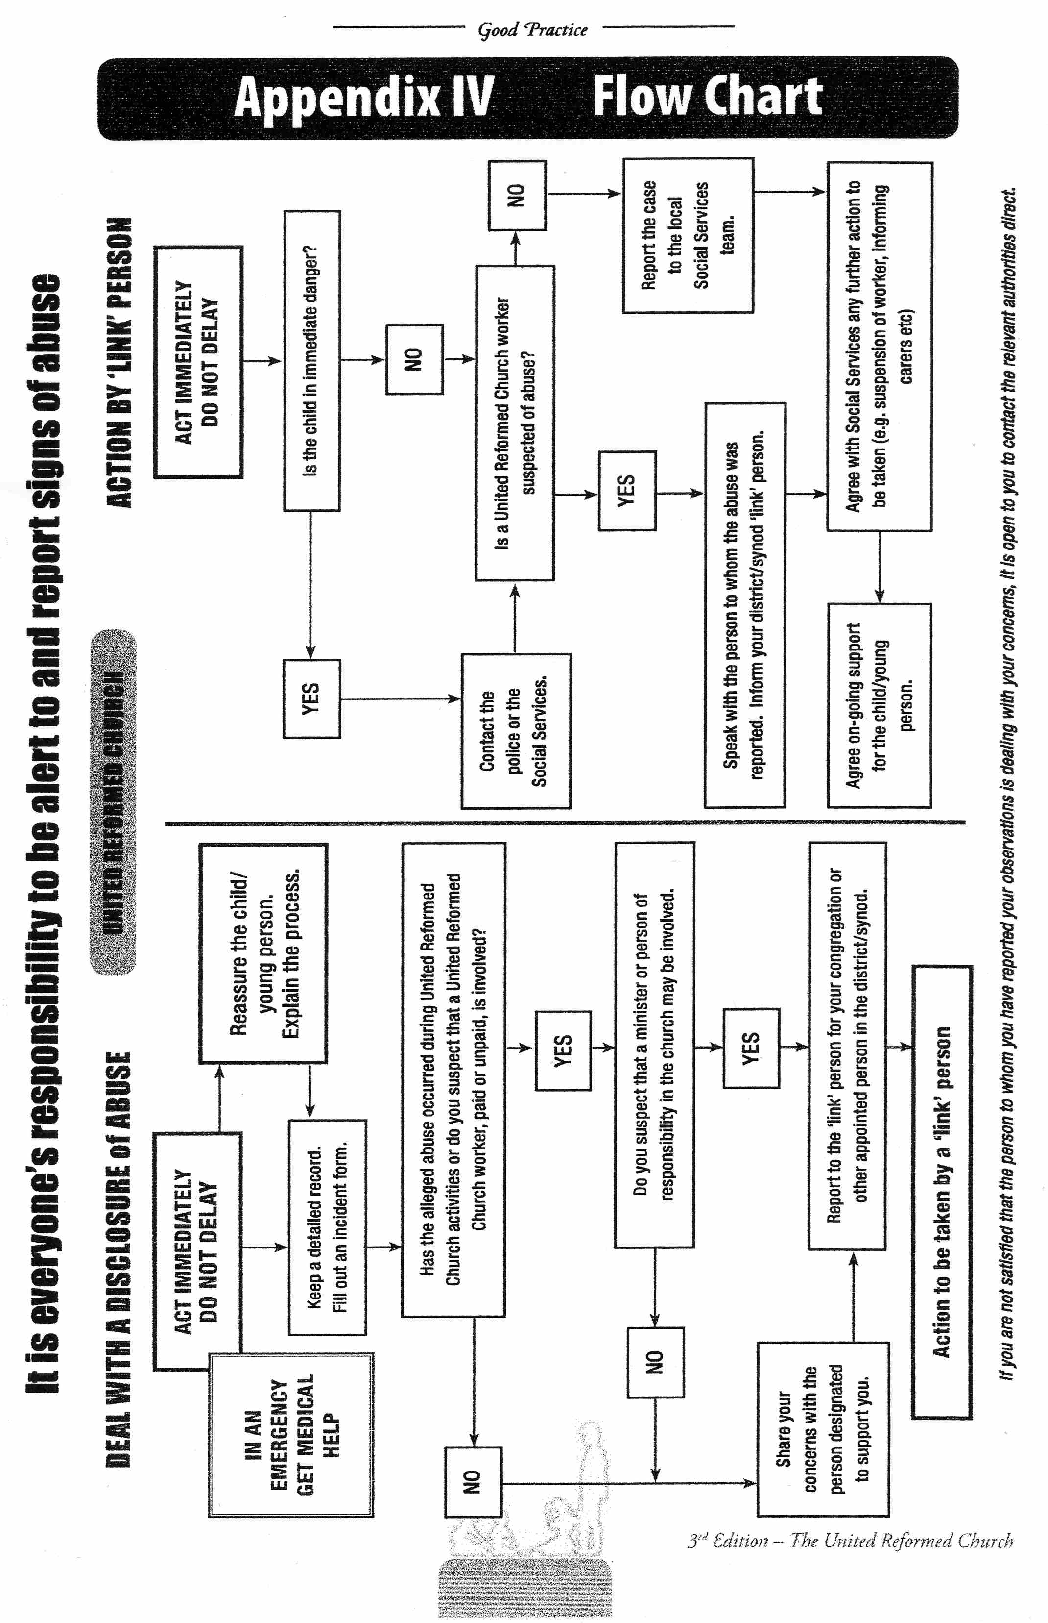

Old Meeting, Tadley United Reformed Church, Volunteer Application Form

The Fun Starts Here!

Thank you for expressing an interest in helping with the Children & Family Work at Old meeting, Tadley URC . We are very grateful for people volunteering their time and energy to this valuable work. As the safety of the children is always paramount we do now require you to fill in a few forms I’m afraid!

Firstly, you will need to complete this volunteer’s form for the Church as an interim measure, but you will also need to go through a police check (a DBS). The DBS form can look a little daunting but Janet Gross is the verifier for these forms, and she will guide you through them. You will need to contact her as soon as possible please on 0118 970 0809 in order to start the process.

Thanks once again.

God bless

Old Meeting, Tadley URC
Volunteer Application Form

PLEASE COMPLETE IN BLACK INK

APPLICATION for working with children

Volunteer Post:

PERSONAL DETAILS
Name:
Address:
Telephone Numbers:
Home: Work: Mobile:
E-mail:
Date of Birth:
If you have lived at the above address for less than three years please give previous addresses with dates:

SKILLS, ABILITIES, KNOWLEDGE AND EXPERIENCE

Why do you want to apply to do this work?

What ability, knowledge, commitment and experience do you have?

What is your church background and current place of worship?
(If it is not the URC a church leader from your current church may be contacted for a reference so please provide a name and address).

REFERENCES

References will be taken up as one way of checking your suitability and to demonstrate the church’s attention to proper care for children.
Please give the name, address and contact number of two people who can provide an assessment of your suitability for the post.
Name 1: Name 2:

Address: Address:

Telephone: Telephone:

Connection with you: Connection with you:

DISCLOSURE OF CRIMINAL CONVICTIONS
Under the Rehabilitation of Offenders Act 1974 ex offenders have to disclose their criminal convictions when applying for exempted posts. Work with children and young people are exempted posts.
Do you have any criminal convictions, cautions or bind overs? Yes No
If you have answered yes please enclose details with your application form.
Is there any information you should declare that might affect your suitability for working with children and young people? Yes No
(e.g. Allegations which have been the subject of investigation; any current criminal investigations)
If you have answered ‘yes’ please enclose details with your application form.

DISCLOSURE
Do you agree to undergo the relevant vetting processes, including ‘Enhanced Disclosure’ through the Due Diligence Check that may be carried out from time to time to establish your identity and your suitability for work with children and young people. The processes are in accordance with legal requirements and Good Practice guidelines of the United Reformed Church: Yes No
(A separate form will be issued for the implementation of this procedure).

DECLARATION
I declare that the information in this application is true and complete. I agree to references being taken up.
If I am successful in obtaining this post and the information is later discovered to be incorrect I understand that the appointment may be cancelled.
Signed:
Date:
Old Meeting, Tadley URC
Current Voluntary roles for Children’s Work, Youth Work and Work with Vulnerable Adults
1. WEEKLY TERM-TIME TODDLER GROUP. ( Little Angels)
The main role for the volunteers is to welcome and befriend the families who visit each week. They also help to keep the registers, supervise the craft table and help to put out and clear away play equipment and do daily safety checks. Helpers are also needed to make and distribute tea and coffee to the parents and juice and biscuits to the children..

JUNIOR CHURCH- meets on occasional Sundays (as and when children come to services) during part of the church service. Volunteers are needed be prepared to lead or assist in supervising children of any age from crèche age to Secondary school aged children. Appropriate study material and some toys are available in the Church school room.

- MESSY CHURCH - This is an ecumenical CTAT venture which is generally based at Tadley Common Methodist Church. It is held bi-monthly. Volunteers provide craft sessions before worship which is followed by a shared meal. It is for children of any age, who are accompanied throughout by a parent or carer.
- ANNUAL HOLIDAY CLUB- This is an ecumenical CTAT venture based at Tadley Common Methodist Church and St. Mary’s church in August. There are separate volunteer forms for this club
- CHRISTMAS LUNCH- This is an ecumenical venture based in Tadley involving entertainment and providing Christmas lunch for vulnerable adults. There are separate volunteer forms for this activity.

I am interested in the volunteer role of…………………………………………………

……………………………………………………………………………

Signed: Date:

Consent Form Example

Consent forms are to be given out to and returned by a child’s parent or guardian before a planned event takes place.

Consent forms always need to be given in conjunction with a covering letter that clearly outlines the planned event. This letter should include details of who is organising the trip, dates, times, venues and transport details as and when necessary (e.g. how the children will be delivered and collected from site or details of transport, if a volunteer is being used as a driver).

Examples of consent and information forms appear below:

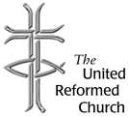

Information & Consent Form
(Normally used for an off-site activity)

Personal details

First name of participant ……………………………………... Surname ………................

Date of birth ………………………. Age ………… male / female

Address………………………………………………………………………………………………………………………

……................................................................... Post code …………………………

Name of next of kin …………………………………………………………………………………………………

Next of kin address during activity (if different from above)…………………………………

………………………………………………………………………………… Post code ………………………….

Contact no: Home………………………. Work…………………….. Mobile…………………………….

Name & address of participant‘s doctor ………………………………………………………………

Telephone no …………………………………. NHS no (if known) …………………………………….

I confirm that I have parental responsibility for …………………………………………………..

He / she is in good health and I consider him/her to be capable of taking part in
the activities set out in your letter dated …………………………… I acknowledge that the insurance synopsis held by the Church can be viewed at any time. I consent to him/her taking part in the programme.

In the event of illness or accident, I consent to any necessary medical treatment, which might include the use of anaesthetics.

Signed ……………………………………………………………………………………………………………………..

Date..........................................................................................................

Please print name here …………………………………………………………………………………………….

Address …………………………………………………………………………………………………………………….

…………………………………………………………………………………………Post code …………………………

Any additional information required please attach on a separate sheet.

Information and Medical Form (please complete)

Has the participant had any of the following?

Asthma or bronchitis Yes No Allergies to any known medication Yes No
Heart condition Yes No Other illness or disability Yes No Severe headaches Yes No Fits, fainting or blackouts Yes No
Travel sickness Yes No Regular medication Yes No
Diabetes Yes No Any other allergies, eg, food, plasters Yes No

If the answer to any of these questions is Yes, please give details ………………….

……………………………………………………………………………………………………………………………..

………………………………………………………………………………………………………………………………….

Has the participant received vaccination against Tetanus
in the last 10 years? Yes No

Is the participant receiving medical or surgical treatment
of any kind from their family doctor or hospital? Yes No

Has the participant been given specific medical advice to
follow in emergencies? Yes No

If the answer to either of these last two questions is Yes, please give details here
(including name and Dosage of any medicines/tablets):

…………………………………………………………………………………………………………………………………….

In the event of any illness or medical treatment occurring after the return of this form and prior to the activity, I undertake to inform the group leader.

Signed…………………………………………………………… (person with parental responsibility)

Please print name here ………………………………………………………………………………………….

Consent for taking images
During the Junior Church meetings we are likely to take pictures and videos. We would like to use these in presentations, displays or in our own booklets, newsletters or publicity.

In the event of any images of my child being taken, I consent to
them being used for educational purposes. Yes No

I understand that if my child is easily identifiable (eg close facial shot) I will be informed first.

I consent to the images being used on the Tadley URC website Yes No

Signed……………………………………………………………..(person with parental responsibility)

Please print name here………………………………………………………… Date…………………………

Consent for Transport

(Only to be completed when planned events involve the transport of children and young adults)

I have read the letter dated …………………………. Concerning the planned trip to
………………………….. on ………………………………(date).

I am happy with the travel arrangements as outlined in the letter and I understand that I am responsible for the supplying and fitting of any car seats necessary for my child/children whilst in transit. We are unable to transport your child without the necessary car seats being supplied.

Signed ……………………………………..

Printed ……………………………………. Date …………………………….

Driver’s details
Name

Age
Address

Telephone no.
Mobile
Emergency contact details
Next of kin
Contact tel. no.
Mobile no.
Tick as appropriate

Declaration

I declare that, to the best of my knowledge, the vehicle to be driven is in
roadworthy condition and is fully taxed and insured.

I declare that I hold a current UK Driving Licence and have had no serious
driving convictions.

I accept responsibility for my passengers during the journey and will
endeavour to make their safe transportation a priority.

Signed …………………………………………

Printed ………………………………………... Dated …………………….

The following section to be completed by Church representative only
Driver’s licence no.
Date of issue
Details of any convictions registered on Licence (phone DVLA on 08702 400009 to check the code of any points shown)
Insurance Details
Insurance date
MOT date (date due)
Signed
Date

Risk Assessment Recording Table

Name of group: ………………………………………………………… Age range of group: …………………

Name of assessor: …………………………………………………….. Date: ………………………………….

Description of potential hazard identified | Control required to reduce risk | Description of action taken

Risk Assessment Recording Table (continuation sheet. Page…..)

Description of potential hazard identified | Control required to reduce risk | Description of action taken

Daily Safety Checklist

 |  | Date | Date | Date | Date | Date | Date | Date | Date | Date | Date | Date | Date
 | Description of area to be checked for safety
1
2
3
4
5
6
7
8
9
10
11
12
13
14
15

